Econometrics & Time Series Applied to Finance

MSc. Finance & Big Data

Group Assingment

DAKKOURI Mohamad, RASLAN Shehab, SINGH Satnam

1. Task 1
   1. Plot of adjusted closing price times series of General Motors (GM) & Ford (F)  
      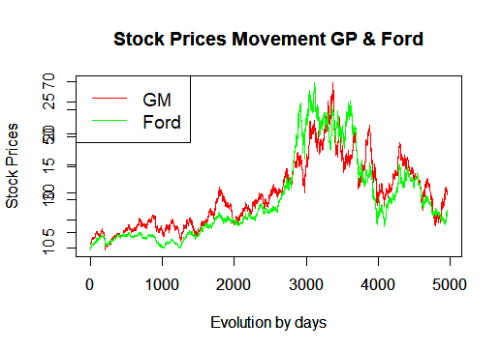  
      The stock prices of both GM & Ford follow the same trend over the period. It can be seen that when the stock prices peaked for the GM (the series in red), the stock prices of Ford (the series in green) followed the same evolution. Same applied when priced dropped towards the end of the period. This can be explained potentially because both companies belong to the same automobile industy.
   2. Plot GM returns against Ford returns

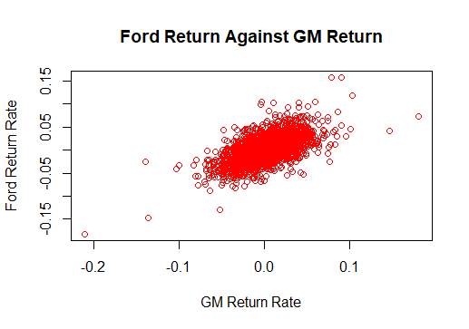

The returns of Ford on the X-axis & GM on the Y-axis depicts a very strong positive correlation despite the few positive and slightly less negative abnormal returns. Graphically, it seems that the abnormal returns of both series occur concurrently. For example, the negative outlier laying at the bottom left of the graph is drawn fron a negative abnormal return for both data series. The Pearson correlation coefficient between the two series is 0.613, a strong positive correlation value.

* 1. Boxplot of GM & Ford returns

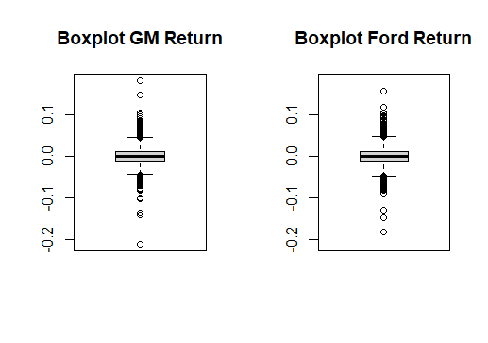

The median of both series is around zero & the majority of returns values are located slightly above zero & slightly below zero in the interquartil range (IQR). Both boxplots have approximately a simiarl maximum (Q3 + 1.5*IQR) and minimum (Q1-1.5IQR) with more positive outliers than negative outliers in both boxplots.

* 1. Repeat the Tasks 1.2 & 1.3 with Microsoft (MSFT) and Merck (MRKfff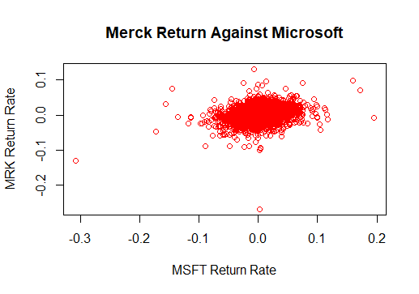

The returns of MSFT & MRK depict a weak postive correlation confirmed by a Pearson correlation coefficient equals to 0.27. Graphically, the retuns data points are scattered around zero with a weak positive trend over time. There are a few outliers aka abnormal returns which occur concurrently for both series being positive or negative.

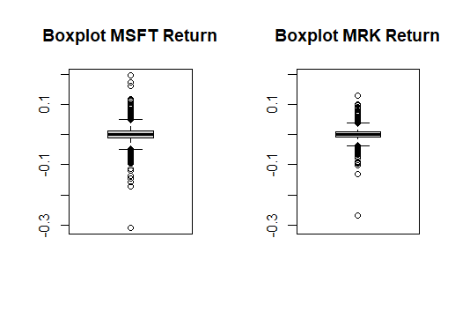

Looking at both boxplots for MSFT & MRK, there is more volatility in the returns of MSFT represented by more positive and negative outliers. Furthermore, the IQR range is wider for MSFT in comparison to MRK. However, we can remark a negative abnormal return approximate to -0.3 for both returns series.

* 1. Descriptive statistics of return series and comment if series can be noramlly distributed or not

|  |  |  |  |  |
| --- | --- | --- | --- | --- |
| **Descriptive Statistics Table** | | | | |
| **Statistic** | GM | F | MSFT | MRK |
| **Mean** | 0.000409 | 0.0004786 | 0.001349 | 0.000624 |
| **Std** | 0.02064121 | 0.02106919 | 0.02430142 | 0.01757261 |
| **skewness** | 0.09220772 | 0.1990671 | -0.2313383 | -0.7511417 |
| **kurtosis** | 6.04964 | 4.671755 | 9.583577 | 14.4101 |
| **median** | 0.000000 | 0.000000 | 0.000000 | 0.000000 |
| **Q1** | -0.011020 | -0.0115883 | -0.010927 | -0.008942 |
| **Q3** | 0.011262 | 0.0120438 | 0.013528 | 0.010114 |
| **Min** | -0.210169 | -0.1820809 | -0.307692 | -0.267757 |
| **Max** | 0.181075 | 0.1575246 | 0.195807 | 0.130124 |

The descriptive statistics table shows multiple key statistics for the four return series of GM, F, MSFT and MRK. MSFT has the highest mean of return at 0.13%, while GM stands lowest at a mean of 0.04%. The volatility of returns oscillates around 0.02 for GM, F, and MSFT, and a bit lower at 0.017 for MRK. In addition, as described by the boxplots above, the IQR for all return series is generally between +0.01 and -0.01, and the median at 0 as shown by the boxplots as well.

A normally distributed dataset would have a skewness equals to 0 and a kurtosis equals to 3. None of the return series above have a skewness equals to 0 with GM returns being the least skewed. Additionally, non of these series have a kurtosis of 3 which means these returns have more returns points in the tails compared to normal distribution tails, in other words higher frequency in the tails compared to noram distribution frequency. This means none of these reutrns can be normally distributed.

1. Task 2
   1. Plot ACF & PCF for all price & return series. Are the prices & returns stationary?

ACF simply it shows the auto-correlation between a series and its past values, while PACF shows the correlation of the residulas after considering the effect of ACF with the next lagged value.

* + 1. 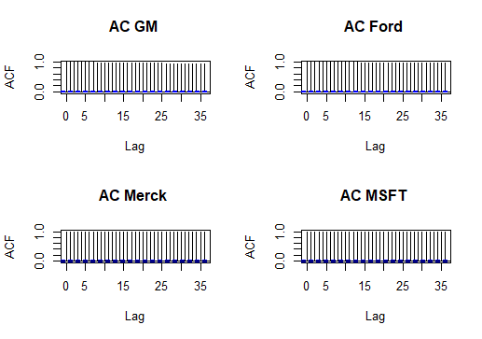Prices

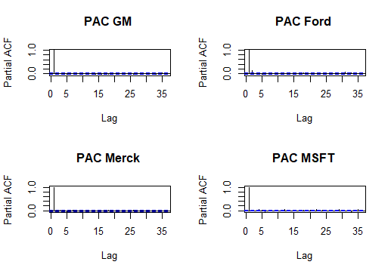

Looking at the ACF & PACF of the prices, there is one spike of the PACF which means an AR(1) process as PACF cuts off afer lag 1. These series are random walk and could be with a drift or without a drift. The prices are not stationary after looking at the PACF.

* + 1. 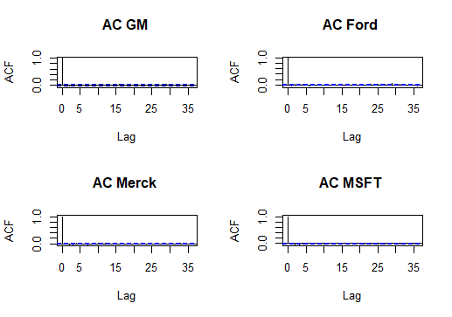Returns

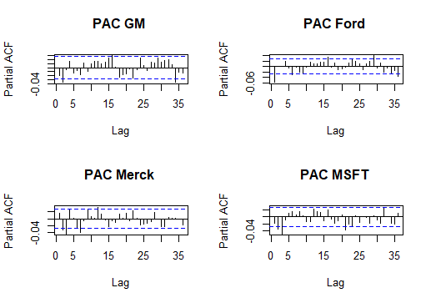Looking at the ACF & Partial ACF of the returns, the returns are not stationary and follows a MA(1) process.

* 1. Stationariy, serial-correlations, homoskedasticity, and normal distribution tests
     1. Prices

|  |  |  |  |  |  |
| --- | --- | --- | --- | --- | --- |
| Test | Null hypothesis | GM | F | MSFT | MRK |
| Stationarity  (ADF) | H0: Unit Root non-stationarity | p-value = 0.2159 | p-value = 0.823 | p-value = 0.4402 | p-value = 0.7138 |
| Serial-correlation  Ljung-Box | H0: No serial correlations | p-value < 2.2e-16 | p-value < 2.2e-16 | p-value < 2.2e-16 | p-value < 2.2e-16 |
| Normality Test  Shapiro_Wilk’s | H0: Normal distribution | p-value < 2.2e-16 | p-value < 2.2e-16 | p-value < 2.2e-16 | p-value < 2.2e-16 |
| Homoskedasticity Test |  |  |  |  |  |

* + 1. Returns

|  |  |  |  |  |  |
| --- | --- | --- | --- | --- | --- |
| Test | Null hypothesis | GM | F | MSFT | MRK |
| Stationarity  (ADF) | H0: Unit Root non-stationarity | p-value = 0.01 | p-value = 0.01 | p-value = 0.01 | p-value = 0.01 |
| Serial-correlation  Ljung-Box | H0: No serial correlations | p-value = 0.1651 | p-value = 2.834e-05 | p-value = 0.2141 | p-value = 0.2763 |
| Normality Test  Shapiro_Wilk’s | H0: Normal distribution | p-value < 2.2e-1 | p-value < 2.2e-16 | p-value < 2.2e-16 | p-value < 2.2e-16 |
| **Homoskedasticity Test** |  |  |  |  |  |

None of the prices series is stationariy while the return series are stationary according the ADF stationarity test. Neither the return series nor the prices series are normally distributed according to Shpiro Wilk’s normality test with a null hypothesis of normal distribution rejected in all the cases. For hetroskedasticity,

Since an AR model would considers previous behavior as input for current behavior to capture for example mean-reversion in trading and the MA model would capture the shocks in earnings or returns for example, we would rather fit an ARMA model to capture botht the AR & MA effect on the return series.

* 1. AR(1) on the General Motors Series

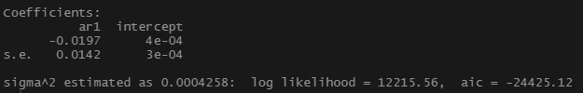

* 1. ARMA-GARCH model for series used in 2.3

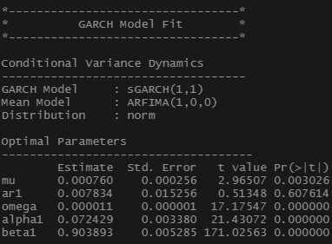

We run the Box Pierce to check if the residuals are white noise and we obtain a P value of 0.58 which means that we fail to reject the null hypothesis of residula indpendence which means that the residuals are white noise.

* 1. EGARCH model



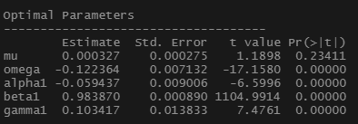

(The E-GARCH model on the return of GM)

The results show that all the parameters are significant except the mu which stands for the mean of returns, while the constant omega and other parametes are statistically significant at 5%.



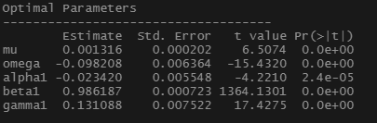

(The E-GARCH model on the return of MSFT)

On the other hand, the test results for the the returns of MSFT show that all the parameters are statistically significant at 5% confidence level. The constant parameter is significant and negative.

* 1. GARCH-DCC Model

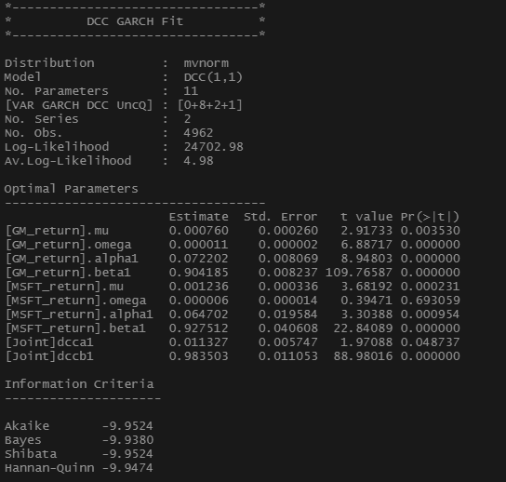

All the parameters of the GARCH-DCC model are significant at 5% except the omega of the MSFT_return. The important parameters to check for a DCC-GARCH model are alpha1, beta1, dcca1, and dccb1. We shall watch the joint significant of alpha1 with beta 1 & dcca1 with dccb1. Since alpha1 & beta1are jointly significant it might be better using a conditional variance over GARCH(1,1). The value of dcca1 nearly zero & dccb1 nearly 1 so we expect the conditional correlation to be increasing over time.

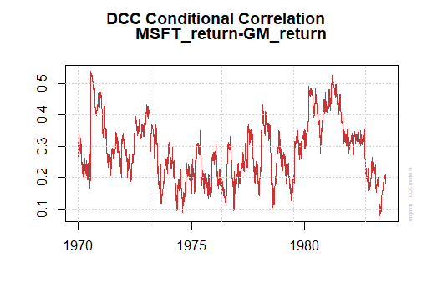

This graph is the conditional correlation ouput after running a GARCH-DCC model on the MSFT return & GM return confirm the results of the DCC-GARCH model that the conditional correlation increasing over with oscillations.

1. Task 3
   1. Data Extractions  
      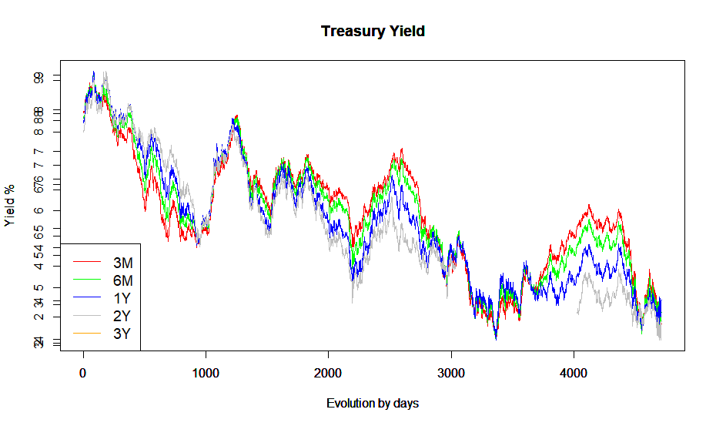
   2. Plotting ACF

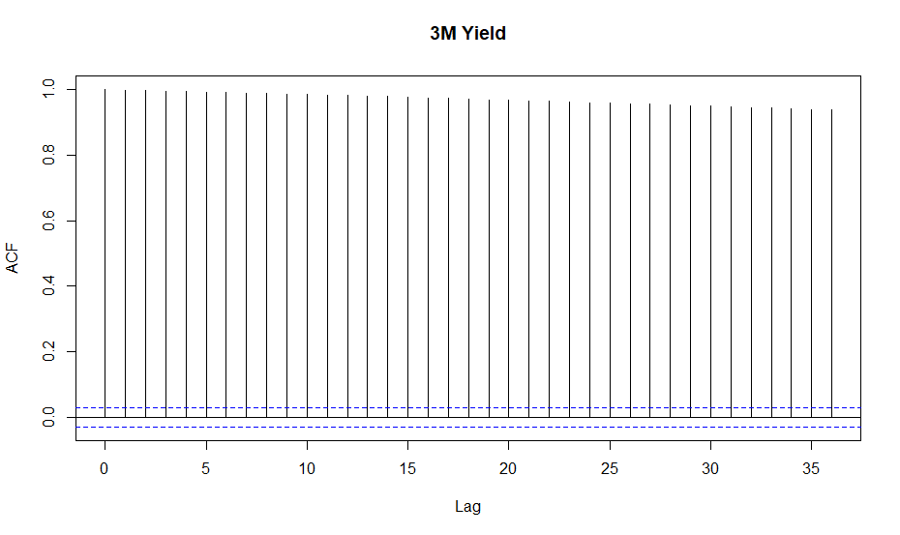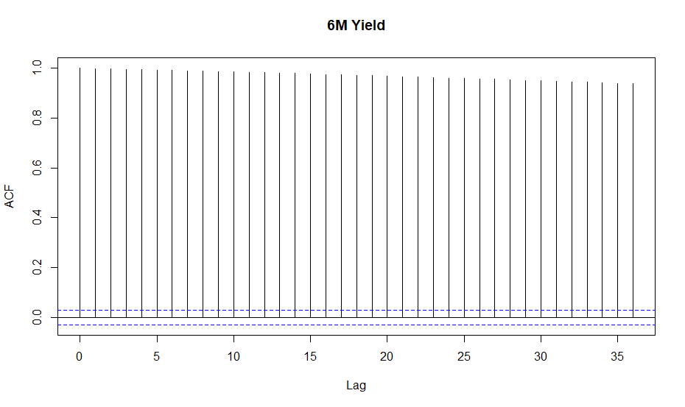

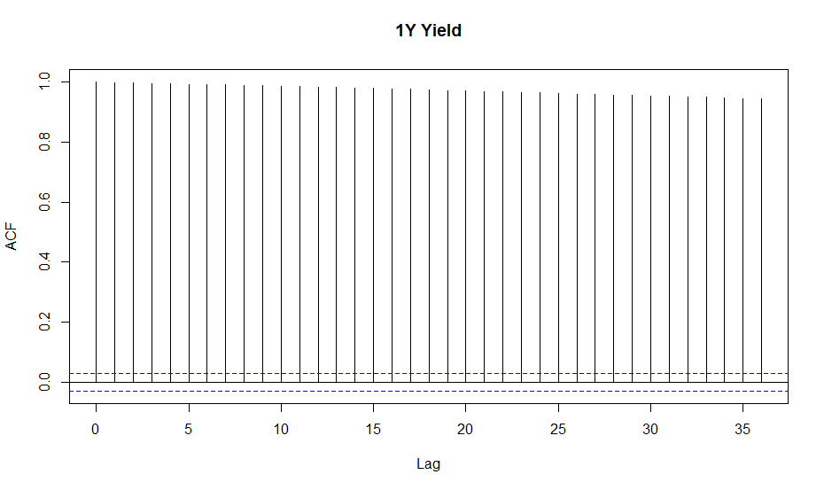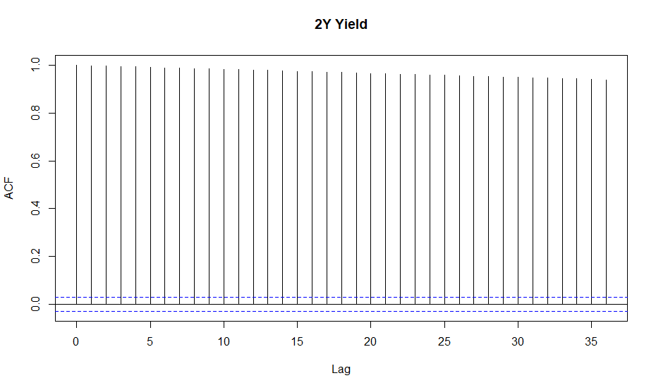

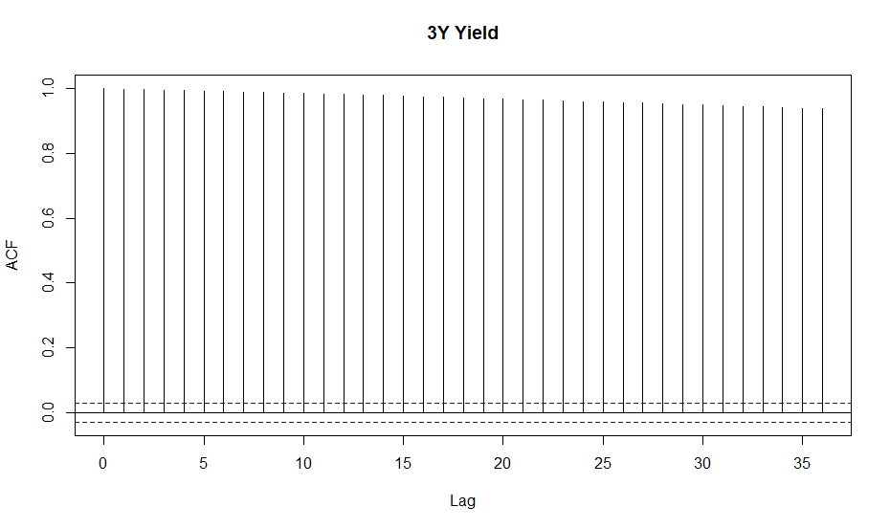

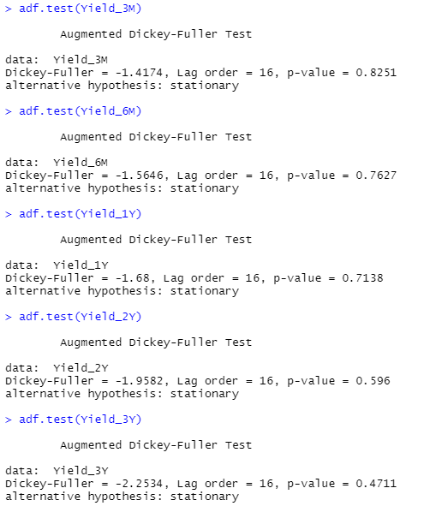

* 1. Correlation Matrix  
     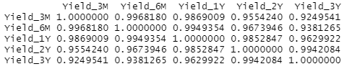

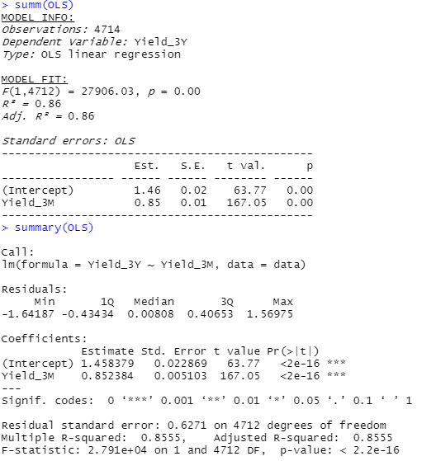

* 1. Residulas
  2. Error Correction Model (ECM)  
     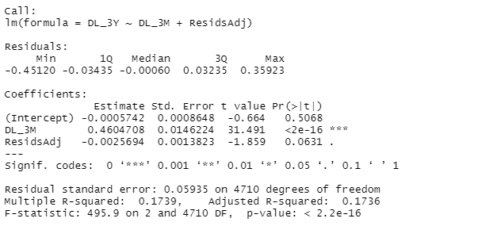
  3. Regression of three month yield on 3-years yield  
     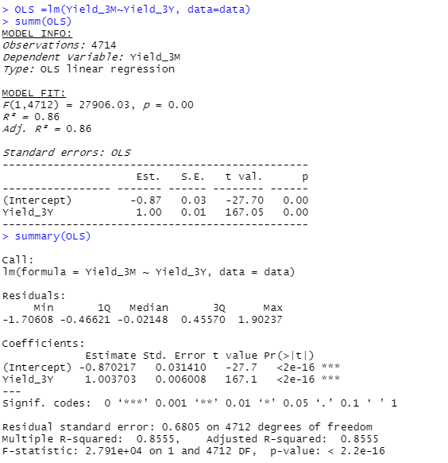

1. Task 4
   1. Data Extractions  
      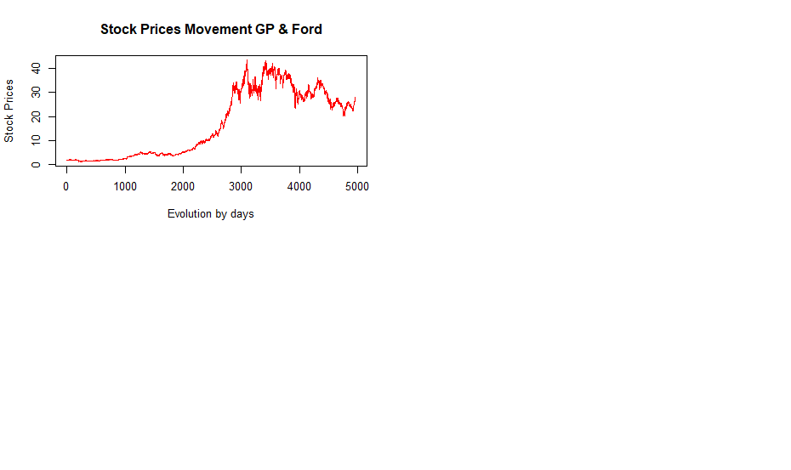

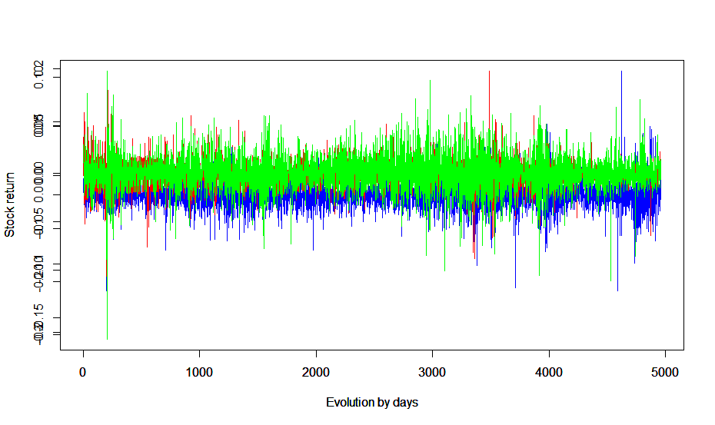

* 1. VAR Model Estimations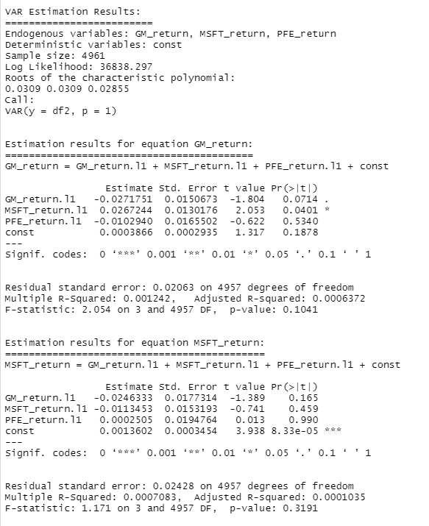

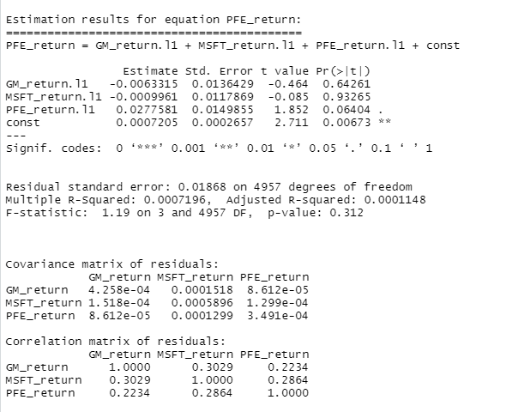

* 1. Granger Causality   
     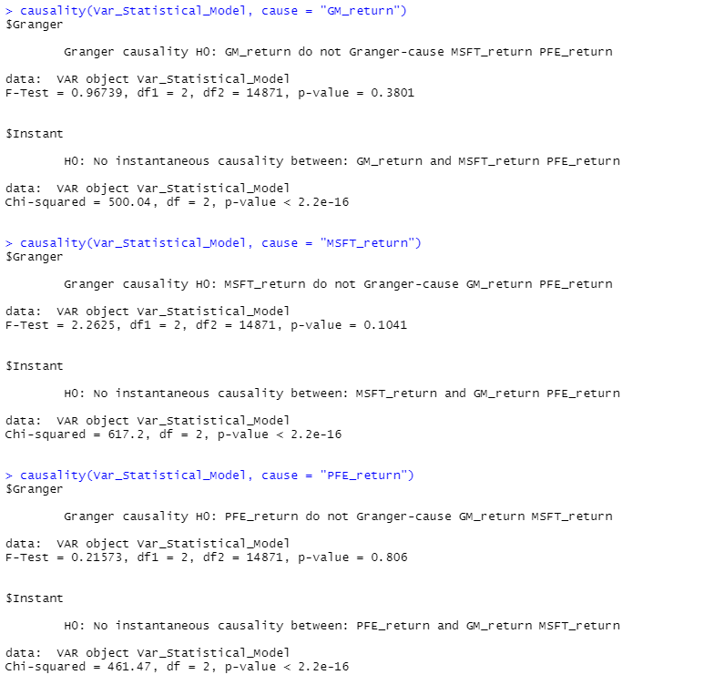
  2. Impulse Responses for the Estimated VAR  
     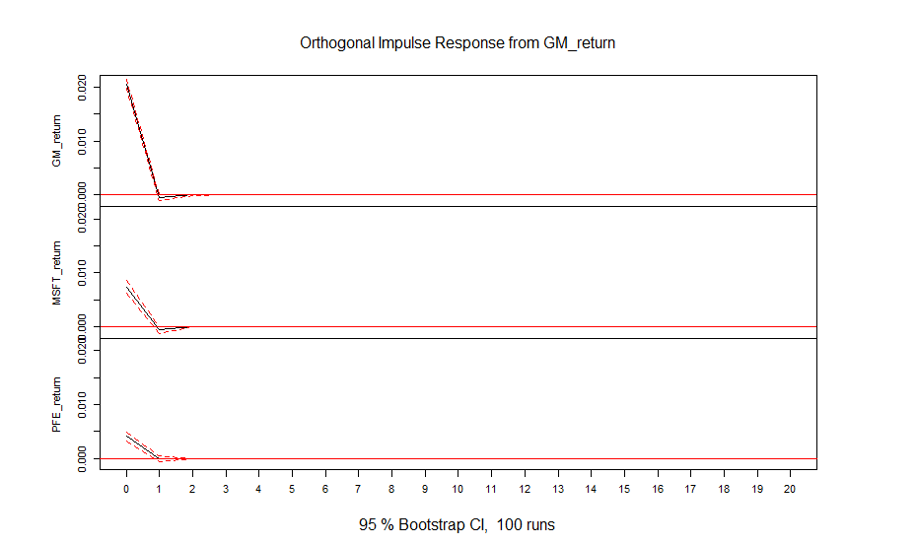
  3. Forecast Error Variance Decomposition (FEVD)

